

CLOUDBRIDGE

DM VALIDATION

TECHNICAL GUIDE

Prepared by Cloudbridge| 20th Dec 2023

@Copyright 2024 Version 1 – All Rights Reserved

**Table of Contents**

1. Introduction 1

1.1 Purpose 1

1.2 Scope and Application 1

2. Overview 1

2.1. About Cloudbridge Validation Reports (Cloudbridge DM) 1

2.2. Configuration 1

3. Executing Validation Process: A Step-by-Step Guide 4

4. Validations List 6

5. Validation Phase Snippets 11

**Version Control**

|  |  |  |  |
| --- | --- | --- | --- |
| Date | Version | Changed By | Reason for Change |
| 20-Dec-2023 | 1.0 | Sinchana Ramesh | No previous version. |
| 10-Mar-2024 | 2.0 | Sinchana Ramesh | Added Cash Receipts, AP Invoices, Purchase Order Receipt Validation Entries. |
| 14-Mar-2024 | 3.0 | Shaik Latheef | Added SUPPLIERS,PO, FA & GL Validation Entries |
| 19-Mar-2024 | 4.0 | Shireesha TR | Added Customers, Customer Tax Banks and Branches and Transactions |
| 20-Mar-2024 | 5.0 | Sinchana Ramesh | Added Validation List for Cash Receipts, AP Invoices, Purchase Order Receipt. |
|  |  |  |  |
|  |  |  |  |
|  |  |  |  |
|  |  |  |  |

Circulation List

|  |  |
| --- | --- |
| Name | Organisation/Title |
| Ken MacMahon | Version 1 |
| Praveen Nair | Version 1 |
| Pallavi Kanajar | Version 1 |
| V1 Cloud Practice | Version 1 |

Glossary

The following terminology and abbreviations are used throughout this document:

|  |  |
| --- | --- |
| Term | Description |
| PO | Purchase Order |
|  |  |
|  |  |
|  |  |

# 1. Introduction

## 1.1 Purpose

This document aims to outline the process related to the recent inclusion of a new enhancement called Validation which has been added to Maximise.

## 1.2 Scope and Application

This document provides the Cloudbridge high-level summary of the Validation process for Data Migration.

This document outlines the following details:

* A concise summary of Validation Reports.
* Details on the necessary configuration for the Validation process.
* An outline of the steps involved in performing Validation.
* Entities in Cloudbridge with Validation Reports.

# 2. Overview

## 2.1. About Cloudbridge Validation Reports (Cloudbridge DM)

Validation Reports play a crucial role in the post-extraction phase, where their primary purpose is to validate the accuracy of the extracted data. This entails verifying that the data aligns with the anticipated format, structure, and established standards. Key aspects of this validation process include checking for adherence to data types and naming conventions, as well as addressing issues like duplicates, missing values, and outliers. Additionally, an essential facet of the validation is the assessment of the extraction process's performance to ensure efficient operation without adverse impacts on the subsequent transform and load processes.

## 2.2. Configuration

The following configurations must be set up for the Validation Phase.

* The installation of the tables listed below needs to be done.
* The installation process for validation tables closely mirrors that of Cloudbridge STG tables, with the distinction of incorporating an additional column, "**Validation_Error_Message**" to convey error messages encountered during the validation phase.
* As of now, there is no file archiving, this will be developed in the future.
* Validation Staging Table or act of staging data in a database table.

|  |  |
| --- | --- |
| Business Entity | Validation Table Name |
| SUPPLIERS | XXMX_AP_SUPPLIERS_VAL |
| SUPPLIER_ADDRESSES | XXMX_AP_SUPP_ADDRS_VAL |
| SUPPLIER_SITES | XXMX_AP_SUPPLIER_SITES_VAL |
| SUPPLIER_CONTACT | XXMX_AP_SUPP_CONTACTS_VAL |
| SUPPLIER_SITE_ASSIGNS | XXMX_AP_SUPP_SITE_ASSIGNS_VAL |
| SUPPLIER_BANK_ACCOUNTS | XXMX_AP_SUPP_BANK_ACCTS_VAL |
| PURCHASE_ORDERS | XXMX_SCM_PO_HEADERS_STD_VAL  XXMX_SCM_PO_DISTRIBUTIONS_STD_VAL  XXMX_SCM_PO_LINE_LOCATIONS_STD_VAL  XXMX_SCM_PO_LINES_STD_VAL |
| INVOICES | XXMX_AP_INVOICES_VAL  XXMX_AP_INVOICE_LINES_VAL |
| TRANSACTIONS | XXMX_AR_TRX_LINES_VAL  XXMX_AR_TRX_DISTS_VAL |
| PURCHASE_ORDER_RECEIPT | XXMX_SCM_PO_RCPT_TXN_VAL  XXMX_SCM_PO_RCPT_HDR_VAL |
| CASH_RECEIPTS | XXMX_AR_CASH_RECEIPTS_VAL |
| FIXED_ASSETS | XXMX_FA_MASS_ADDITIONS_VAL  XXMX_FA_MASS_ADDITION_DIST_VAL  XXMX_FA_MASS_RATES_VAL |
| OPEN_BAL | XXMX_GL_OPENING_BALANCES_VAL |
| SUMM_BAL | XXMX_GL_SUMMARY_BALANCES_VAL |
| DETAIL_BAL | XXMX_GL_DETAIL_BALANCES_VAL |
| CUSTOMERS | XXMX_HZ_PARTIES_VAL  XXMX_HZ_PARTY_SITES_VAL  XXMX_HZ_PARTY_SITE_USES_VAL  XXMX_HZ_CUST_ACCOUNTS_VAL  XXMX_HZ_CUST_ACCT_SITES_VAL  XXMX_HZ_CUST_SITE_USES_VAL  XXMX_HZ_CUST_ACCT_CONTACTS_VAL  XXMX_HZ_CONTACT_POINTS_VAL  XXMX_HZ_ORG_CONTACT_ROLES_VAL  XXMX_HZ_ORG_CONTACTS_VAL  XXMX_HZ_LOCATIONS_VAL  XXMX_HZ_RELATIONSHIPS_VAL  XXMX_HZ_ROLE_RESPS_VAL  XXMX_HZ_CUST_PROFILES_VAL |
| CUSTOMER_TAX | XXMX_ZX_TAX_PROFILE_VAL  XXMX_ZX_TAX_REGISTRATION_VAL  XXMX_ZX_PARTY_CLASSIFIC_VAL |
| BANKS_AND_BRANCHES | XXMX_BANKS_VAL  XXMX_BANK_BRANCHES_VAL |

* Configuration of Metadata is required for specific Business Entity, Addition of three new columns will be added to the **XXMX_MIGRATION_METADATA** table.

|  |  |  |  |
| --- | --- | --- | --- |
| BUSINESS_ENTITY | VAL_PACKAGE_NAME | VAL_PROCEDURE_NAME | VAL_TABLE |
| SUPPLIERS  SUPPLIER_ADDRESSES  SUPPLIER_SITES  SUPPLIER_CONTACT  SUPPLIER_SITE_ASSIGNS  SUPPLIER_BANK_ACCOUNTS | XXMX_SUPPLIER_VALIDATIONS_PKG | VALIDATE_SUPPLIER_PROFILES  VALIDATE_SUPPLIER_ADDRESSES  VALIDATE_SUPPLIER_SITES  VALIDATE_SUPPLIER_CONTATCS  VALIDATE_SUPPLIER_SITE_ASSIGN  VALIDATE_SUPPLIER_BANK_ACCTS | XXMX_AP_SUPPLIERS_VAL  XXMX_AP_SUPP_ADDRS_VAL  XXMX_AP_SUPPLIER_SITES_VAL  XXMX_AP_SUPP_CONTACTS_VAL  XXMX_AP_SUPP_SITE_ASSIGNS_VAL  XXMX_AP_SUPP_BANK_ACCTS_VAL |
| PURCHASE_ORDERS | XXMX_PO_VALIDATIONS_PKG | VALIDATE_PO_HEADERS  VALIDATE_PO_DISTRIBUTIONS  VALIDATE_PO_LINE_LOCATIONS  VALIDATE_PO_LINES | XXMX_SCM_PO_HEADERS_STD_VAL  XXMX_SCM_PO_DISTRIBUTIONS_STD_VAL  XXMX_SCM_PO_LINE_LOCATIONS_STD_VAL  XXMX_SCM_PO_LINES_STD_VAL |
| INVOICES | XXMX_INVOICES_VALIDATIONS_PKG | VALIDATE_INVOICE_HEADERS  VALIDATE_INVOICE_LINES | XXMX_AP_INVOICES_VAL  XXMX_AP_INVOICE_LINES_VAL |
| TRANSACTIONS | XXMX_AR_INVOICE_VALIDATION_PKG | VALIDATE_AR_LINES  VALIDATE_AR_DISTRIBUTIONS | XXMX_AR_TRX_LINES_VAL  XXMX_AR_TRX_DISTS_VAL |
| PURCHASE_ORDER_RECEIPT | XXMX_PO_RCPT_VALIDATIONS_PKG | VALIDATE_PO_RCPT_HEADERS  VALIDATE_PO_RCPT_TRANSACTIONS | XXMX_SCM_PO_RCPT_TXN_VAL  XXMX_SCM_PO_RCPT_HDR_VAL |
| CASH_RECEIPTS | XXMX_RECEIPTS_VALIDATION_PKG | VALIDATE_CASH_RECEIPTS | XXMX_AR_CASH_RECEIPTS_VAL |
| FIXED_ASSETS | XXMX_FA_VALIDATIONS_PKG | VALIDATE_MASS_ADDITION  VALIDATE_FA_MASS_ADDITION_DIST  VALIDATE_MASSRATES | XXMX_FA_MASS_ADDITIONS_VAL  XXMX_FA_MASS_ADDITION_DIST_VAL  XXMX_FA_MASS_RATES_VAL |
| OPEN_BAL | XXMX_GL_OPEN_BAL_VAL_PKG | VALIDATE_GL_OPEN_BALANCES | XXMX_GL_OPENING_BALANCES_VAL |
| SUMM_BAL | XXMX_GL_SUMMARY_BAL_VAL_PKG | VALIDATE_GL_SUMMARY_BALANCES | XXMX_GL_SUMMARY_BALANCES_VAL |
| DETAIL_BAL | XXMX_GL_DETAIL_BAL_VAL_PKG | VALIDATE_GL_DETAIL_BALANCES | XXMX_GL_DETAIL_BALANCES_VAL |
| CUSTOMERS | XXMX_CUSTOMER_VALIDATIONS_PKG | VALIDATE_PARTIES  VALIDATE_PARTY_SITES  VALIDATE_PARTY_SITE_USES  VALIDATE_CUST_ACCOUNTS  VALIDATE_CUST_ACCT_SITES  VALIDATE_CUST_ACCTSITE_USES  VALIDATE_ACCT_CONTACTS  VALIDATE_CONTACT_POINTS  VALIDATE_ORG_CONTACT_ROLES  VALIDATE_ORG_CONTACTS  VALIDATE_LOCATIONS  VALIDATE_RELATIONSHIPS  VALIDATE_ROLE_RESPS  VALIDATE_CUST_PROFILES | XXMX_HZ_PARTIES_VAL  XXMX_HZ_PARTY_SITES_VAL  XXMX_HZ_PARTY_SITE_USES_VAL  XXMX_HZ_CUST_ACCOUNTS_VAL  XXMX_HZ_CUST_ACCT_SITES_VAL  XXMX_HZ_CUST_SITE_USES_VAL  XXMX_HZ_CUST_ACCT_CONTACTS_VAL  XXMX_HZ_CONTACT_POINTS_VAL  XXMX_HZ_ORG_CONTACT_ROLES_VAL  XXMX_HZ_ORG_CONTACTS_VAL  XXMX_HZ_LOCATIONS_VAL  XXMX_HZ_RELATIONSHIPS_VAL  XXMX_HZ_ROLE_RESPS_VAL  XXMX_HZ_CUST_PROFILES_VAL |
| CUSTOMER_TAX | XXMX_CUSTOMER_VALIDATIONS_PKG | VALIDATE_TAX_PROFILE  VALIDATE_TAX_REG  VALIDATE_TAX_CLASSIFIC | XXMX_ZX_TAX_PROFILE_VAL  XXMX_ZX_TAX_REGISTRATION_VAL  XXMX_ZX_PARTY_CLASSIFIC_VAL |
| BANKS_AND_BRANCHES | XXMX_BANK_BRANCH_VALS_PKG | VALIDATE_BANKS  VALIDATE_BANK_BRANCHES | XXMX_BANKS_VAL  XXMX_BANK_BRANCHES_VAL |

# 3. Executing Validation Process: A Step-by-Step Guide

Consider the following steps when performing the validation process.

* The validation package follows the following naming convention.

**XXMX_SUPPLIER_VALIDATIONS_PKG** – For Suppliers.

**XXMX_PO_VALIDATIONS_PKG** – For Purchase Orders.

**XXMX_INVOICES_VALIDATIONS_PKG** – For Invoices.

**XXMX_AR_INVOICE_VALIDATION_PKG** – For Transactions.

**XXMX_PO_RCPT_VALIDATIONS_PKG –** For Purchase Order Receipt**.**

**XXMX_RECEIPTS_VALIDATION_PKG –** For Cash Receipts**.**

**XXMX_FA_VALIDATIONS_PKG–** For Fixed Assets**.**

**XXMX_GL_OPEN_BAL_VAL_PKG–** For Opening Balances**.**

**XXMX_GL_SUMMARY_BAL_VAL_PKG–** For Summary Balances**.**

**XXMX_GL_DETAIL_BAL_VAL_PKG–** For Detail Balances**.**

**XXMX_CUSTOMER_VALIDATIONS_PKG –** For Customers**.**

**XXMX_CUSTOMER_VALIDATIONS_PKG –** For Customer Tax**.**

**XXMX_BANK_BRANCH_VALS_PKG –** For Banks and Branches

* Each procedure within the validation package is designed at the sub-entity level, featuring one main procedure aligned with the Business-Entity level, while the remainder of the package structure adheres to the extract package format.

|  |  |  |
| --- | --- | --- |
| Business Entity | Sub Entity | Procedure Name |
| SUPPLIERS | SUPPLIERS | XXMX_AP_SUPPLIERS_VAL |
| SUPPLIER_ADDRESSES | SUPPLIER_ADDRESSES | XXMX_AP_SUPP_ADDRS_VAL |
|  | SUPPLIER_THIRD_PARTY_RELS | XXMX_AP_SUPP_ADDRS_VAL |
| SUPPLIER_SITES | SUPPLIER_SITES | XXMX_AP_SUPPLIER_SITES_VAL |
| SUPPLIER_CONTACT | SUPPLIER_CONTACTS | XXMX_AP_SUPP_CONTACTS_VAL |
|  | SUPPLIER_CONT_ADDRS | XXMX_AP_SUPP_CONTACTS_VAL |
| SUPPLIER_SITE_ASSIGNS | SUPPLIER_SITE_ASSIGNS | XXMX_AP_SUPP_SITE_ASSIGNS_VAL |
| SUPPLIER_BANK_ACCOUNTS | SUPPLIER_BANK_ACCOUNTS | XXMX_AP_SUPP_BANK_ACCTS_VAL |
|  | SUPPLIER_PAYEES | XXMX_AP_SUPP_BANK_ACCTS_VAL |
|  | SUPPLIER_PMT_INSTRS | XXMX_AP_SUPP_BANK_ACCTS_VAL |
| PURCHASE_ORDERS | PO_HEADERS_STD | XXMX_SCM_PO_HEADERS_STD_VAL |
|  | PO_LINES_STD | XXMX_SCM_PO_DISTRIBUTIONS_STD_VAL |
|  | PO_LINE_LOCATIONS_STD | XXMX_SCM_PO_LINE_LOCATIONS_STD_VAL |
|  | PO_DISTRIBUTIONS_STD | XXMX_SCM_PO_LINES_STD_VAL |
| INVOICES | INVOICE_HEADERS | XXMX_AP_INVOICES_VAL |
|  | INVOICE_LINES | XXMX_AP_INVOICE_LINES_VAL |
| TRANSACTIONS | LINES | VALIDATE_AR_LINES |
|  | DISTRIBUTIONS | VALIDATE_AR_DISTRIBUTIONS |
| PURCHASE_ORDER_RECEIPT | PO_RECEIPT_TRANSACTIONS | VALIDATE_PO_RCPT_HEADERS |
|  | PO_RECEIPT_HEADERS | VALIDATE_PO_RCPT_TRANSACTIONS |
| CASH_RECEIPTS | CASH_RECEIPTS | VALIDATE_CASH_RECEIPTS |
| FIXED_ASSETS | MASS_ADDITIONS | VALIDATE_MASS_ADDITION |
|  | MASS_DISTRIBUTION | VALIDATE_FA_MASS_ADDITION_DIST |
|  | MASS_RATES | VALIDATE_MASSRATES |
| OPEN_BAL | OPEN_BAL | VALIDATE_GL_OPEN_BALANCES |
| SUMM_BAL | SUMM_BAL | VALIDATE_GL_SUMMARY_BALANCES |
| DETAIL_BAL | DETAIL_BAL | VALIDATE_GL_DETAIL_BALANCES |
| CUSTOMERS | PARTIES | VALIDATE_PARTIES |
|  | PARTY_SITES | VALIDATE_PARTY_SITES |
|  | PARTY_SITES_USES | VALIDATE_PARTY_SITE_USES |
|  | CUSTOMER_ACCOUNTS | VALIDATE_CUST_ACCOUNTS |
|  | CUSTOMER_ACCOUNTS_SITES | VALIDATE_CUST_ACCT_SITES |
|  | ACCOUNT_SITES_USES | VALIDATE_CUST_ACCTSITE_USES |
|  | CUST_ACCT_CONTACT | VALIDATE_ACCT_CONTACTS |
|  | CONTACT_POINTS | VALIDATE_CONTACT_POINTS |
|  | CONTACT_ROLES | VALIDATE_ORG_CONTACT_ROLES |
|  | ORG_CONTACTS | VALIDATE_ORG_CONTACTS |
|  | LOCATIONS | VALIDATE_LOCATIONS |
|  | RELATIONSHIPS | VALIDATE_RELATIONSHIPS |
|  | ROLES_AND_RESPONSIBILITIES | VALIDATE_ROLE_RESPS |
|  | CUSTOMER_PROFILES | VALIDATE_CUST_PROFILES |
| CUSTOMER_TAX | TAX_PROFILE | VALIDATE_TAX_PROFILE |
|  | TAX_REGISTRATION | VALIDATE_TAX_REG |
|  | PARTY_CLASSIFICATION | VALIDATE_TAX_CLASSIFIC |
| BANKS_AND_BRANCHES | BANKS | VALIDATE_BANKS |
|  | BANK_BRANCHES | VALIDATE_BANK_BRANCHES |

* Validation script commands for execution:

**EXEC XXMX_SUPPLIER_VALIDATIONS_PKG.VALIDATE_SUPPLIERS('FIN','AP','SUPPLIERS');**

**EXEC XXMX_PO_VALIDATIONS_PKG.VALIDATE_PURCHASE_ORDERS('SCM','PO','PURCHASE_ORDERS');**

**EXEC XXMX_INVOICES_VALIDATIONS_PKG.VALIDATE_INVOICES('FIN','AP','INVOICES');**

**EXEC XXMX_AR_INVOICE_VALIDATION_PKG.VALIDATE_RECEIVABLES('FIN','AR','TRANSACTIONS');**

**EXEC XXMX_PO_RCPT_VALIDATIONS_PKG.VALIDATE_PO_RCPT('SCM','PO','PURCHASE_ORDER_RECEIPT');**

**EXEC XXMX_RECEIPTS_VALIDATION_PKG.VALIDATE_CASH_RECEIPTS('FIN','AR','CASH_RECEIPTS');**

**EXEC XXMX_FA_VALIDATIONS_PKG.** **VALIDATE_FIXED_ASSETS ('FIN','FA','** **FIXED_ASSETS');**

**EXEC XXMX_GL_OPEN_BAL_VAL_PKG.** **VALIDATE_OPEN_BALANCES ('FIN','GL','** **OPEN_BAL');**

**EXEC XXMX_GL_SUMMARY_BAL_VAL_PKG.** **VALIDATE_BALANCES ('FIN','GL','** **SUMM_BAL');**

**EXEC XXMX_GL_DETAIL_BAL_VAL_PKG.** **VALIDATE_DETAIL_BALANCES ('FIN','GL','** **DETAIL_BAL');**

**EXEC XXMX_CUSTOMER_VALIDATIONS_PKG.VALIDATE_CUSTOMERS('FIN','ZX',** **CUSTOMER_TAX);**

**EXEC XXMX_CUSTOMER_VALIDATIONS_PKG.VALIDATE_CUSTOMERS('FIN','AR','CUSTOMERS');**

**EXEC XXMX_BANK_BRANCH_VALS_PKG.VALIDATE_BANKS_AND_BRANCHES('HCM','HR','BANKS_AND_BRANCHES');**

* The execution of the validation phase is currently limited to the back end using PL/SQL; however, future plans involve its development for the front end using VBCS.

# 4. Validations List

|  |  |  |
| --- | --- | --- |
| Business Entity | Sub Entity | Procedure Name |
| SUPPLIERS | SUPPLIERS | * Validate Supplier Records getting duplicated * Validate Supplier name getting duplicated * Validate Supplier TRN is duplicated * Validate Supplier Name having Junk / Invalid characters * Validate Suppliers when the Federal Reportable flag is Y/N |
| SUPPLIER_ADDRESSES | SUPPLIER_ADDRESSES | * Validate Supplier Address Records getting duplicated * Validate Supplier Name having Junk / Invalid characters |
| SUPPLIER_SITES | SUPPLIER_SITES  SUPPLIER_THIRD_PARTY_RELS | * Validate Supplier Site Name having Junk / Invalid characters * Validate Supplier Sites whose Remittance Advice Delivery Method is null however Remittance Email or Remittance Fax is not null * Validate Supplier Sites where Hold Reason cannot be null when the supplier has been applied any of the three 'Hold from Payment' holds * Validate Supplier Sites where Address Name is blank * Validate Supplier Sites where Pay Site Flag or Purchasing Site Flag is 'Y' and where RFQ Only Site Flag = 'Y' |
| SUPPLIER_CONTACT | SUPPLIER_CONTACTS  SUPPLIER_CONT_ADDRS | * Validate Supplier Contact with First Name null or Email Address null or Email address not having ‘@’ |
| SUPPLIER_SITE_ASSIGNS | SUPPLIER_SITE_ASSIGNS | * Validate Supplier Site match or not |
| SUPPLIER_BANK_ACCOUNTS | SUPPLIER_PAYEES  SUPPLIER_BANK_ACCOUNTS  SUPPLIER_PMT_INSTRS | * Validate Supplier Payee * Validate Supplier Bank Name having Junk / Invalid characters |
| PURCHASE_ORDERS | PO_HEADERS_STD | * Validate if PO is open but Vendor/Vendor Site is inactive * Validate if Buyer is an active employee * Validate Supplier Sites whose Remittance Advice Delivery Method is null however Remittance Email or Remittance Fax is not null * Validate if PO Header has at least one PO Line |
|  | PO_LINES_STD | * Validate if unit price value exceeds 10 decimal places * Validate if PO Line has at least one PO header * Validate if PO Line has at least one PO Line Location |
|  | PO_LINE_LOCATIONS_STD | * Validate if PO Line Location has at least one PO Line * Validate if PO Line Location has at least one PO Distribution * Validate if PO Line Quantity matches with PO Line Location Quantity * Validate if PO Line Amount matches with PO Line Location Amount |
|  | PO_DISTRIBUTIONS_STD | * Validate if Requestor is an active employee * Validate if Project is closed or not * Validate if Task is closed or not when Project is Open * Validate if PO Distribution has at least one PO Line Location * Validate if PO Line Location Quantity matches with PO Distribution Quantity * Validate if PO Line Location Amount matches with PO Distribution Amount |
| FIXED_ASSETS | MASS_ADDITIONS | * Validate if Asset Cost is not a zero * Validate the Asset type * Validate the ytd impairment * Validate if MASS_ADDITION_ID column is null * Validate if the asset number are unique are not * Validate the posting status * Validate the Asset Description having the Junk/Invalid Characters * Validate if Fa mass addition ID has at least one fa mass distribution |
|  | MASS_DISTRIBUTION | * Validate if UNITS column is NULL * Validate if EMAIL is valid * Validate if fa mass distribution ID has at least one Fa mass addition ID |
|  | MASS_RATES | * Validate if MASS_ADDITION_ID column is null * Validate if fa mass Rates has at least one Fa mass addition ID |
| OPEN_BAL | OPEN_BAL | * Validate if entered credit and entered debit is matching for summary balances: we have considered segment 1 as balancing segment * Validate if ACCOUTNED credit and entered debit is matching for summary balances: we have considered segment 1 as balancing segment * Validate if entered cr has 0 * Validate if entered dr has 0 * Validate if accounted dr has 0 * Validate if accounted dr has 0 * Validate if period name is in wrong format * Validate if junk/invalid characters are present |
| SUMM_BAL | SUMM_BAL | * Validate if entered credit and enetered debit is matching for summary balances: we have considered segment 1 as balancing segment * Validate if ACCOUNTED credit and enetered debit is matching for summary balances: we have considered segment 1 as balancing segment * Validate if entered cr has 0 * Validate if entered dr has 0 * Validate if accounted dr has 0 * Validate if accounted dr has 0 * Validate if period name is in wrong format * Validate if junk/invalid characters are present |
| DETAIL_BAL | DETAIL_BAL | * Validate if entered credit and entered debit is matching for summary balances: we have considered segment 1 as balancing segment * Validate if ACCOUNTED credit and entered debit is matching for summary balances: we have considered segment 1 as balancing segment * Validate if entered cr has 0 * Validate if entered dr has 0 * Validate if accounted dr has 0 * Validate if accounted dr has 0 * Validate if period name is in wrong format * Validate if junk/invalid characters are present |
| CUSTOMERS | PARTIES | * Validate if Party name is having junk/invalid character * Validate if Party Orig System Reference is unique or not * Validate if Party Type is valid or not |
|  | PARTY_SITES | * Validate if Party Site Orig System Reference is unique or not * Validate if Party site has at least one party orig system reference * Validate only one site has identifying_address_flag='Y' if a party has multiple sites * Validate if Location Original System Reference is valid or not |
|  | PARTY_SITE_USES | * Validate if Site Orig System Reference is valid or not * Validate if Party site has at least one site use original system reference * Validate if Date Range is valid or not |
|  | CUSTOMER_ACCOUNTS | * Validate if Customer Account name is having junk/invalid character * Validate if Party Orig System Reference is valid or not |
|  | CUSTOMER_ACCOUNTS_SITES | * Validate if Site Orig System Reference is valid or not * Validate if Date Range is valid or not - Party Sites * Validate if Date Range is valid or not - Cust Accounts |
|  | ACCOUNT_SITES_USES | * Validate if Cust Site Orig System Reference is valid or not * Validate if Customer site has at least one Customer site use original system reference * Validate if Date Range is valid or not - Account Sites |
|  | CUST_ACCT_CONTACT | * Validate if Party Orig System Reference is valid or not * Validate if customer account source system reference is valid or not * Validate if Cust Site Orig System Reference is valid or not |
|  | CONTACT_POINTS | * Validate if Party Orig System Reference is valid or not. * Validate if Site Orig System Reference is valid or not. * Validate if contact point email address is valid or not. |
|  | CONTACT_ROLES | * Validate if Party Orig System Reference is valid or not. * Validate if Relationship Source System Reference is valid or not. |
|  | ORG_CONTACTS | * Validate if Party Orig System Reference is valid or not. |
|  | LOCATIONS | * Validate if Customer Address data having junk/invalid characters. |
|  | RELATIONSHIPS | * Validate if Party Orig System Reference is valid or not. |
|  | ROLES_AND_RESPONSIBILITIES | * Validate if Party Orig System Reference is valid or not. * Validate if Customer Contact Source System Reference is valid or not. |
|  | CUSTOMER_PROFILES | * Validate incorrect flags. * Validate if customer account source system reference is valid or not. * Validate if Cust Site Orig System Reference is valid or not. |
| CUSTOMER_TAX | TAX_PROFILE | * Validate if Party name has junk/invalid character. * Validate if Process for Applicability Flag has valid values or not. * Validate if Rounding Level Code has valid values or not. * Validate if Rounding Rule Code has valid values or not. * Validate if Inclusive Tax Flag has valid values or not. * Validate if Allow Offset Tax Flag has valid values or not. |
|  | TAX_REGISTRATION | * Validate if Party name has junk/invalid character. * Validate if Default Registration Flag has valid values or not. * Validate if Rounding Rule Code has valid values or not. * Validate if Self Assess Flag has valid values or not. * Validate if Inclusive Tax Flag has valid values or not. |
|  | PARTY_CLASSIFICATION | * Validate if Party name has junk/invalid character. |
| BANKS_AND_BRANCHES | BANKS | * Within same Country there cannot be a Bank name with same Bank numbers. * Validate country column data as it should have 2 digit ISO code and not full country name. * Validate if country column is null. * Validate bank_name having Junk / Invalid characters. * Validate alternate_bank_name having Junk / Invalid characters. * Validate short_bank_name having Junk / Invalid characters. |
|  | BANK_BRANCHES | * Validate if data uses 2 digit ISO code and not full country name. * validate if country is null. * Within same Country there cannot be a Bank name, bank branch Name and same bank branch numbers. * Validate bank branch Name having Junk / Invalid characters. * validate if bank branch name is null in bank_branches. * Validate short_bank_name having Junk / Invalid characters. |
| TRANSACTIONS | LINES | * Validate Customer Account Number (ORIG_SYSTEM_BILL_CUSTOMER_REF) is Not present. * Validate Customer Account Site (ORIG_SYSTEM_BILL_ADDRESS_REF) is Not present. * Validate when transcation type is manual then trascation number is there are not, if it is not there enter manually. * Validate transcation line quantity should not be zero(0). |
|  | DISTRIBUTIONS | * Validate concatened segments from Gl code combination table. * Validate percent is null. |
| INVOICES | INVOICE_HEADERS | * Validate Invoice Records getting duplicated. * Validate Supplier name Not present. * Validate Supplier number Not present. * Validate Supplier Site Not present. * Validate Supplier Name having Junk / Invalid characters. * Validate pay site flag is not set to Y. * Validate vendor site is inactive. * Validate Invoice Amount according to Invoice Type. * Validate Invoice Amount does not Match with Line Amount. * Validate if AP Header has at least one AP Line. * Validate Description is having junk. * Validate vendor/vendor site is inactive. |
|  | INVOICE_LINES | * Validate if AP Lines has at least one AP Header. * Validate Distribution Combination code is blank. * Validate Description is having junk. |
| CASH_RECEIPTS | CASH_RECEIPTS | * Validate receipt Records getting duplicated. * Validate CUSTOMER_NUMBER not present. * Validate bill to location not present. |
| PURCHASE_ORDER_RECEIPT | PO_RECEIPT_TRANSACTIONS | * Validate Supplier name Not present. * Validate if Vendor/Vendor Site is inactive. * Validate if Vendor Site is inactive. * Validate if Customer number is not present. * Validate if Employee Id is not present. * Validate if Requestor is an active employee- used to populate receivers name. * Validate if Requestor is an active employee comparing employee name with requestor in Po. * Validate if POR Header has at least one POR Line. * Validate if Duplicate records are present. |
|  | PO_RECEIPT_HEADERS | * Validate if shipment numbers in transaction is present in header. * Validate if document number is not present in PO. * Validate if POR transaction line has at least one POR header. * Validate Supplier name Not present. * Validate if Vendor/Vendor Site is inactive. * Validate if Vendor Site is inactive. * Validate if deliver to person is an active employee. * Validate if Customer number is not present. |

# 5. Validation Phase Snippets

* **Validation Phase for Supplier looks like below.**

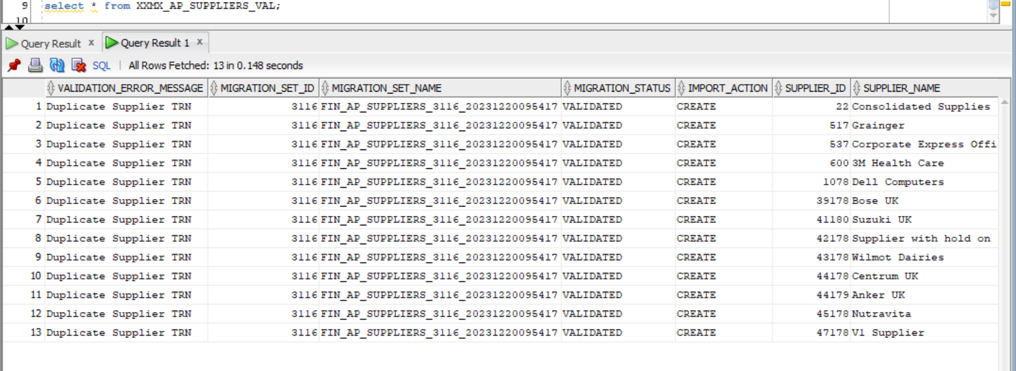

* **Validation Phase for Purchase Orders looks like below.**

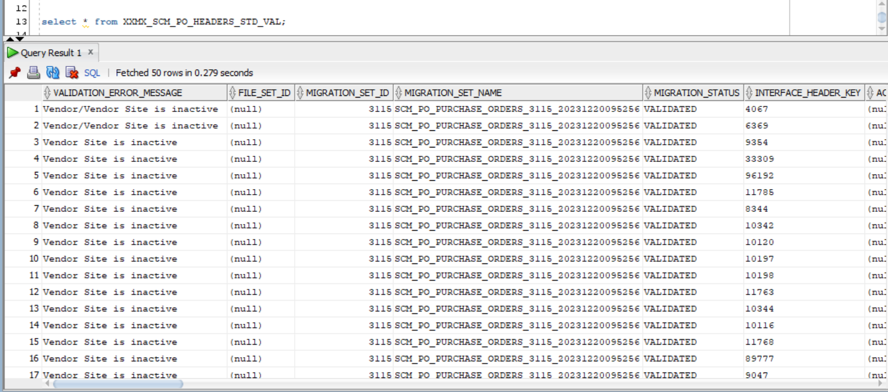

* **Validation Phase for Invoices looks like below.**

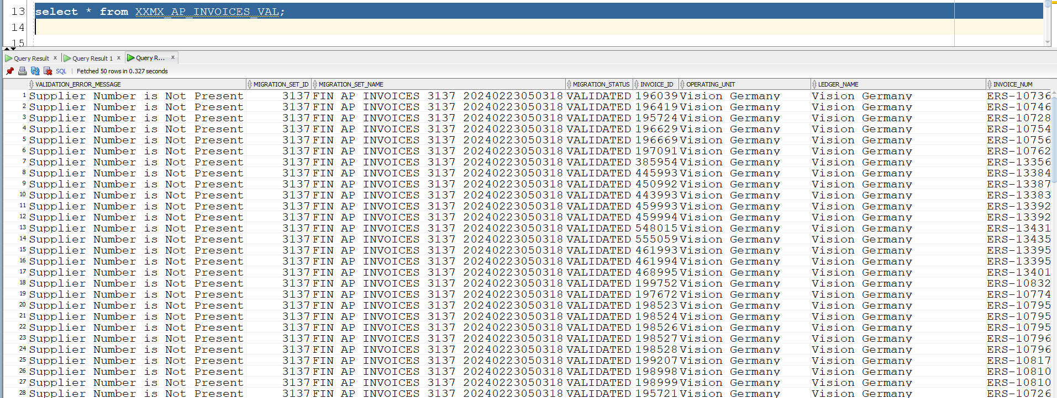

* **Validation Phase for Transactions looks like below.**

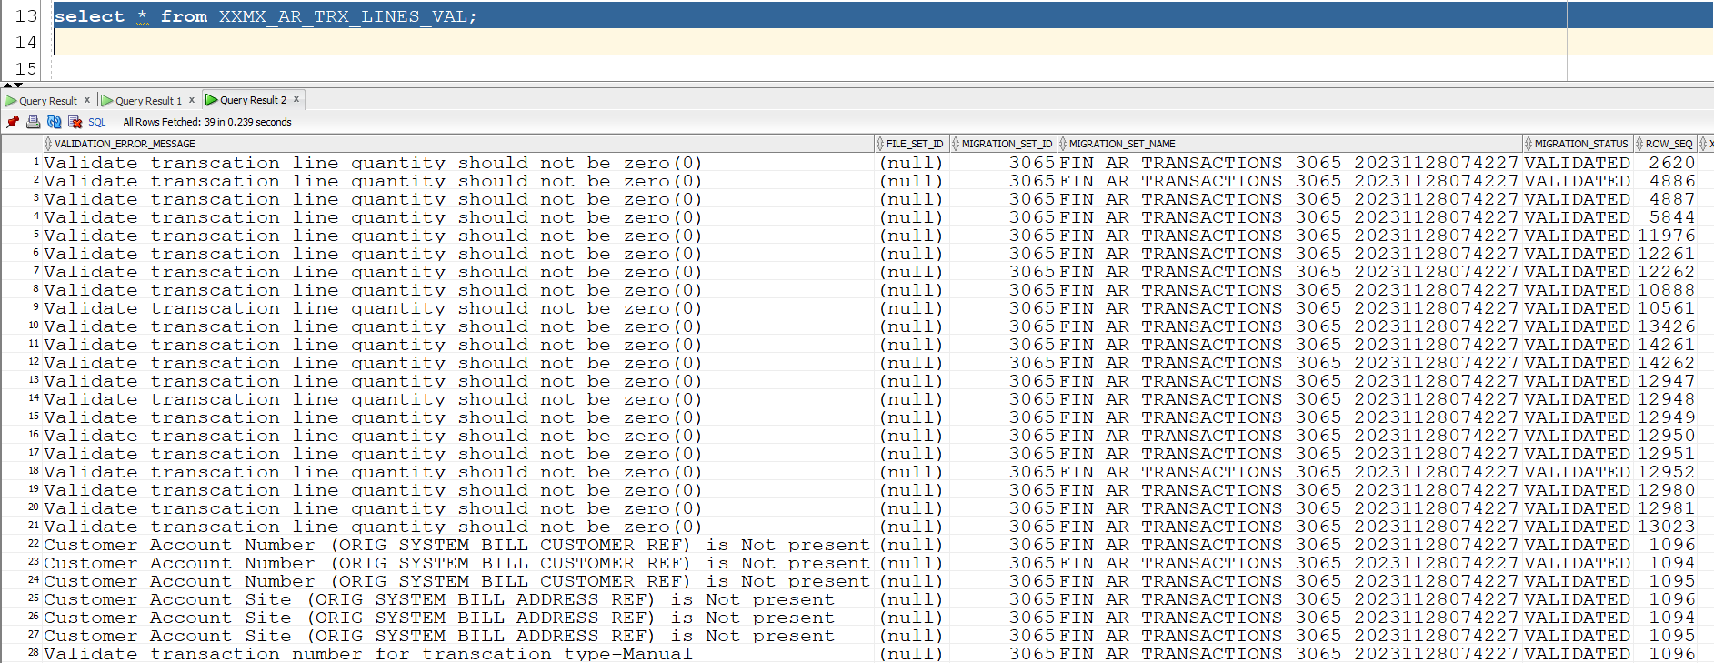

* **Validation Phase for Purchase Order Receipt looks like below.**

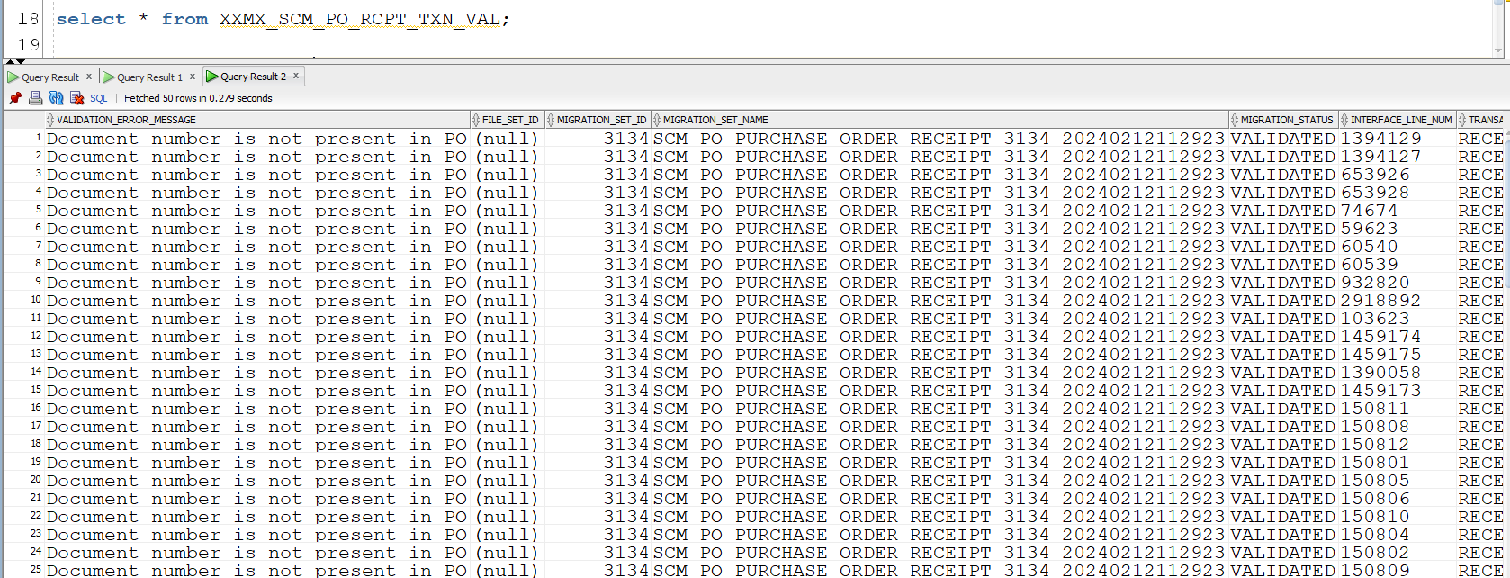

* **Validation Phase for Cash Receipts looks like below.**





[**www.version1.com**](http://www.version1.com)

*`*